Resources I used.

<https://ordinarycoders.com/blog/article/testing-django-selenium>

<https://www.youtube.com/watch?v=XnSQ6sRGKzI>

Make sure you are in your virtual environment.

Install Selenium: pip install django selenium

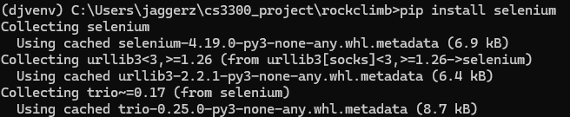

Next find your browser driver. First find out what version your browser is on, for example mine is Chrome and version 123.0.6312.124.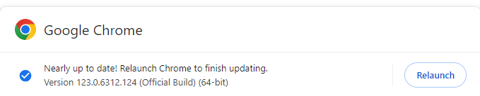

Next, find where to install your driver. I used these two links to find my correct driver.

<https://chromedriver.chromium.org/downloads> <https://googlechromelabs.github.io/chrome-for-testing/#stable>

Next, after downloading the correct driver create a folder named Webdrivers in you C:

Inside there place your driver. 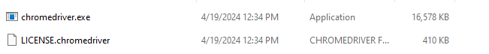

Set PATH Environment Variable:

* + On Windows 10 and Windows 11:
    - Search for 'Environment Variables' in your Windows search box.
    - Select "Edit the system environment variables".
    - In the System Properties window, click on "Environment Variables...".
    - Under "System variables", find and select the Path variable, then click "Edit...".
    - In the "Edit Environment Variable" window, click "New" and add the path to the directory where chromedriver.exe is located.
    - Click "OK" on all open windows to apply the changes.

Now test your selenium to make sure it's working correctly. Use the following code and put it in your test.py file. 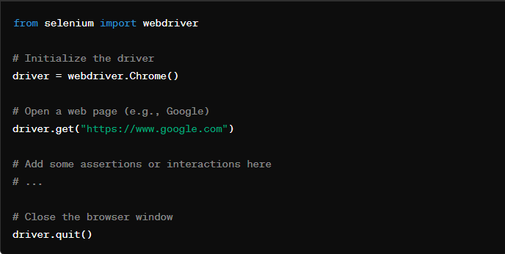

Now run this command in your virtual environment. Python manage.py test.

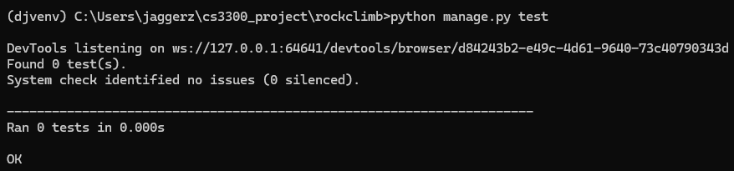

You know it worked correctly if your browser opened.

Now you are all set to start making tests using selenium.